## **Ocean warming and increased light availability rather support productivity of green than brown and red macroalgae in the Mediterranean Sea**

Leonie Hesse*1, Merlin Weiss2, Selma D. Mezger1, Yusuf C. El-Khaled1,3, Alexandra Kler Lago1, Mischa Schwarzmeier4, Christian Wild1

*1University of Bremen, Faculty of Biology and Chemistry, Department of Marine Ecology, Leobener Str. 6, 28359 Bremen, Germany*

*2Department of Environmental Systems Science, ETH Zurich, Universitätstrasse 16, 8092 Zurich, Switzerland*

*3Red Sea Research Center (RSRC), Division of Biological and Environmental Science and Engineering (BESE), King Abdullah University of Science and Technology (KAUST), Thuwal, Saudi Arabia*

*4Institut für Marine Biologie (ifMB), Karlsruhe, Germany*

*E-mail of the corresponding author: leohesse@uni-bremen.de

## 

**Potential Journals:**

- Journal of Experimental Marine Biology and Ecology (Q2, IF 1.8, good fit, long review time)

- Marine Environmental Research (Q2, IF 3.0, more ambitious, good fit, more quick)

- Frontiers in Marine Science Global Change and the Future Ocean (Q1, IF 2.8, good fit)

- Springer; e.g., Marine Biology (Q2, IF 2.4, goof fit)

**To Do (all co-authors):**

- Proofreading, commenting, add contributions on last page

Note: **please use track changes and add any additional citations in red**

**To Do (Leonie):**

- Incorporate comments/edits/feedback

- Format text, references, decimals, figures, etc. to journal guidelines (after we choose a journal)

**Abstract**

Global change is rapidly altering temperature and light regimes in marine environments, yet the physiological sensitivity to shifts in these features remains poorly understood for many primary producers. In the Mediterranean, red (*Phyllophora spp.*), brown(*Cystoseira* spp.) and green (*Flabellia spp.*) macroalgae represent functionally distinct ecosystem engineers that overgrow rocky substrates or seagrass meadows. Their taxon-specific responses to changing temperature and light regimes may have long-lasting effects on algal community composition and the broader ecosystem, but have so far not been quantified. Here, we experimentally examined how variations in water temperatures and light availability affect photosynthesis (P) and respiration (R) in these macroalgae. We collected 161 specimens from these genera around Giglio Island (Italy) and measured their oxygen fluxes in a full-factorial design combining three temperatures (21, 26, and 30 °C) and light intensities (180, 320, and 760 µM quanta m-2 s-1). Both temperature and light significantly influenced net photosynthesis, with marked taxon-specific responses. *Cystoseira* was most strongly negatively affected under combined factors, with photosynthesis nearly ceasing at 30 °C and 760 µM quanta m⁻² s⁻¹, also reflected in a critically low P:R ratio under the same conditions (1.3 ± 0.1). In contrast, *Phyllophora* maintained stable photosynthetic rates under high light conditions and showed slightly elevated photosynthesis rates with warming and a moderate decline in its P:R ratio (3.7 ± 0.4). *Flabellia* sustained net photosynthesis under moderate light intensity and outperformed *Cystoseira* at high temperature and light, with the highest P:R ratio (3.8 ± 0.4) under maximal stress. Our findings suggest that *Cystoseira* may decline in ocean warming scenarios due to physiological limits, while *Phyllophora* may persist and *Flabellia* may even thrive. This could have far-reaching consequences for habitat complexity and biodiversity, as *Flabellia* – unlike the architecturally complex and persistent *Cystoseira* – does not form stable, three-dimensional habitats for associated communities.

**Keywords**: Macroalgal Physiology, Stress Responses, Oxygen Flux, Climate Change, Metabolic Balance, Community Shifts, Ecological Plasticity

## 

## 

## **Introduction**

Global change is altering the physical and biological conditions of marine ecosystems, particularly in semi-enclosed seas such as the Mediterranean. Climate change and anthropogenic disturbance have direct consequences for many primary producers, including ecosystem engineers like benthic macroalgae (Pastor et al., 2018). Among the most critical environmental drivers that control the physiology, growth, and distribution of photosynthetic organisms are water temperature and light availability, which regulate metabolic processes and define ecological niche spaces (Raven & Geider, 2003). In the Mediterranean, the frequency and intensity of marine heatwaves, i.e., prolonged periods of anomalously high water temperatures, have increased markedly and caused mass mortalities in over 50 taxa from surface waters down to 45 m depth (Garrabou et al., 2009; Hobday et al., 2018) Concurrently, the thermocline, i.e., the transitional layer between water masses of differing temperatures – typically positioned between 10–30 m depth (Romero et al., 2023) – is expected to form earlier and persist longer under future warming scenarios. This may lead to increased water column stratification and limit vertical nutrient flux (Somot et al., 2006; Parras-Berrocal et al., 2020). This may suppress phytoplankton biomass, leading to clearer surface layers and increased light penetration to greater depths (Li et al., 2024). While such changes may initially enhance light availability for benthic macroalgae, the associated nutrient limitation and altered light availability can also disrupt primary production dynamics and shift competitive balances within phototrophic communities (Karlsson et al., 2009). At the same time, local anthropogenic stressors, for example eutrophication, sediment runoff, and coastal development, also modulate water clarity by increasing turbidity and reducing light availability (Cloern et al., 2014; Szalińska et al., 2024). Therefore, both temperature and light regimes are expected to undergo substantial change due to the effects of climate change and anthropogenic disturbance, and likely influence physiology, productivity, and community structure of marine primary producers (D’Ortenzio & Ribera d’Alcalà, 2009; Trégarot et al., 2024; Uitz et al., 2010).

Macroalgae are among the most abundant primary producers in coastal systems (Tait & Schiel, 2018), modifying habitat structure and supporting diverse assemblages of invertebrates, fish, and epiphytes (Trégarot et al., 2024b). In the Mediterranean, functionally distinct taxa occupy different ecological niches. For example, the red algae *Phyllophora* spp. forms dense mats on rocky substrates, creating complex microhabitats that attenuate currents and light penetration, support a high diversity of invertebrates, and enhance overall benthic biodiversity (Schmidt et al., 2021). The brown alga *Cystoseira* spp. forms underwater forests whose three-dimensional structure enhances biodiversity by providing an important habitat for invertebrates, fish, and epiphytic algae (Mancuso et al., 2024; Verdura et al., 2019). The green alga *Flabellia* spp. inhabits well-lit hard substrates, often occurring in phytocoenosis associated with *Posidonia oceanica* meadows, where it contributes to benthic stability and hosts epiphytic taxa such as calcareous algae and tube worms (Díaz et al., 2019).

However, climate-driven shifts in species performance are increasingly evident. These may include declines in large, canopy-forming macroalgae and the proliferation of opportunistic or turf-forming species (Gao et al., 2021). Warming may also promote the invasion of heat-adapted taxa such as *Ulva* spp. (Ji & Gao, 2021) or non-native species in the mediterranean, e.g., *Sargassum muticum*, which displace native communities by forming dense overgrowths (Tiralongo et al., 2022; Tsirintanis et al., 2022). Also, *Phyllophora* and *Cystoseira* were observed to dominate in seagrass meadows that were exposed to warming and eutrophication, causing a transition toward simplified, algal-dominated assemblages (El-Khaled et al., 2023).

The photosynthetic performance of macroalgae is strongly regulated by environmental factors such as temperature and light availability, which influence both energy production and respiration (Raven & Hurd, 2012; Reiskind et al., 1989). Therefore, these shifts are likely underpinned by species-specific differences in photosynthetic and metabolic responses to environmental stress. Net photosynthesis typically increases with temperature up to a species-specific optimum beyond which enzyme denaturation and rising respiration can result in net carbon loss (Crafts-Brandner & Salvucci, 2000; Maltsev et al., 2021). This balance is often expressed as the photosynthesis-to-respiration (P:R) ratio, which serves as a proxy for metabolic performance (Vásquez-Elizondo et al., 2022). Under low light or high temperature, P:R ratios may fall below unity, indicating a shift toward heterotrophy (Wiencke et al., 1993). Excess light stress can further reduce photosynthetic capacity via photoinhibition (Hanelt, 1995), although some macroalgae benefit from elevated light and temperature through enhanced carbon assimilation (Shi et al., 2021).

Despite the importance of temperature and light for shaping macroalgal physiology, their combined effects on photosynthetic performance and metabolic balance remain poorly understood, particularly for Mediterranean macroalgae (Ji et al., 2016). Here, we investigated how variable temperature and light conditions affect oxygen fluxes in three ecologically distinct macroalgae: the red alga *Phyllophora*, the brown alga *Cystoseira*, and the green alga *Flabellia*. We quantify net (P) and gross photosynthesis, respiration (R), and P:R ratio under full-factorial combinations of temperature and light stress to assess species-specific resilience and the potential for anthropogenic-driven shifts in community composition.

Specifically, we asked (i) how ocean warming influences oxygen fluxes in green, brown, and red macroalgae; (ii) how changes in light availability modulate these fluxes; (iii) and whether temperature and light interact to produce synergistic effects on macroalgal metabolism. We hypothesised that rising temperatures would reduce net photosynthesis and photosynthesis-to-respiration (P:R) ratios, with species-specific variation reflecting differences in thermal optima and metabolic flexibility. Similarly, we expected photosynthetic performance to increase with light availability up to a taxon-specific threshold, beyond which photoinhibition would impair carbon assimilation. Finally, we expected that temperature and light would interact synergistically, with dual stress amplifying metabolic impairment and favouring opportunistic, stress-tolerant species.

To test this, we conducted a controlled laboratory experiment in which all three algae were exposed to a full-factorial combination of temperature light stress, aiming to provide insights into the resilience of Mediterranean macroalgae and their potential to persist or decline under future shifts in temperature and light regimes.

## 

## 

## 

## **Material & Methods**

*Study site*

We conducted the experiment in September 2021 at the laboratory facilities of the Institute for Marine Biology (IfmB) on Giglio Island, Italy. We collected algae specimens by scuba diving at the Punta del Fenaio dive site (42°23’19.98”N, 10°52’47.92”E) on the island’s northwestern coast, within the Tuscan Archipelago National Park, Tyrrhenian Sea. Sampling occurred at depths of 20–22 m, where *Phyllophora* and *Cystoseira* co-dominate the benthic community, and *Flabellia* grows on nearby hard substrates. All specimens were collected within a 10 m radius to ensure that individuals had experienced similar environmental conditions, allowing for direct interspecific comparisons under controlled laboratory conditions.

*Data collection and experimental design*

We randomly collected specimens of *Phyllophora*, *Cystoseira*, and *Flabellia* from rocky substrates. While morphological traits indicated that most individuals likely represented *Phyllophora crispa* and *Flabellia petiolata*, species-level identification was less certain for *Cystoseira*, where more than one species may have been present. To ensure consistency and avoid taxonomic overreach, we retained all specimens at the genus level for subsequent analyses and accounted for potential within-genus variability. Each specimen was carefully detached and immediately transferred into 2 L Kautex jars filled with ambient seawater. Upon return to the laboratory all samples were placed into flow-through husbandry tanks and maintained under stable conditions (20 °C, 12:12 h light/dark cycle) with light levels comparable to *in situ* conditions. We conducted incubation experiments to quantify metabolic rates (net photosynthesis, gross photosynthesis, and respiration) under ambient conditions (20 °C, 180 µmol photons m⁻² s⁻¹) and under two elevated temperature treatments (26 °C and 30 °C) and two elevated light treatments (320 and 760 µmol photons m⁻² s⁻¹) (see Fig. 1).

*Metabolism measurements*

All metabolism incubations were conducted *ex situ* and within 3 days after sample collection. For the O2 flux measurements, incubation chambers (560 mL volume) were filled exclusively with ambient seawater collected the same day, and algal material was placed carefully inside the incubation chambers (n = 6 for *Phyllophora,* *Cystoseira* and *Flabellia*, respectively). Additionally, 4 chambers without specimens served as controls to correct for planktonic background metabolism. All chambers were sealed gas-tight and without any air enclosure. During the incubations, the chambers were randomly placed in a tempered water bath (depending on the respective scenario) and constantly stirred (200 rpm) to ensure stable measurement conditions. Water baths were kept at respective target temperatures. A 2-hour light incubation was followed by a 1.5 h dark incubation. O­2 levels were measured immediately before starting the respective incubations and directly afterwards using a WTW Multi 3430 which was equipped with a WTW DFO 925 O2 sensor.

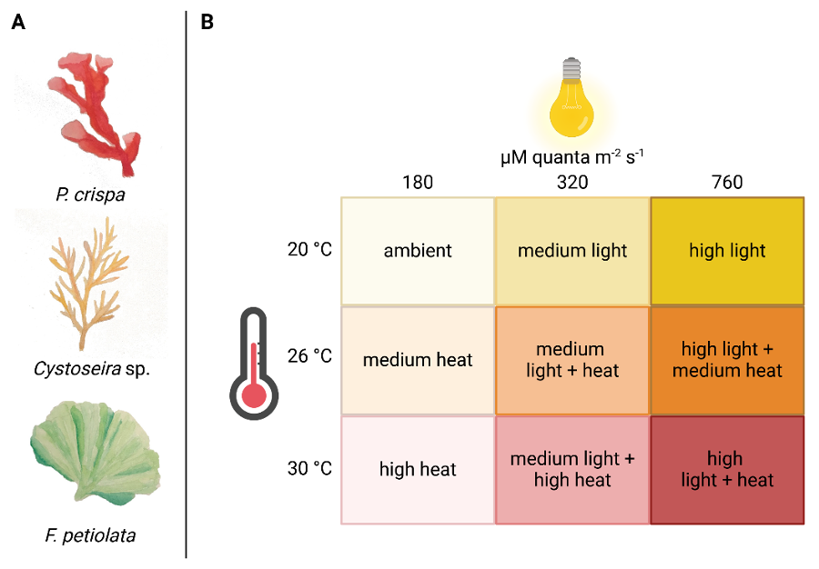

***Figure 1****: Experimental design showing A) the three studied algal species, and B) the cross-factorial design of light and temperature stress the algal samples were exposed to during oxygen flux incubations.*

Measured values from light and dark incubations were used to calculate net primary production (Pnet) and dark respiration (Rdark): O2 start concentrations were subtracted from end concentrations and results were then normalized to incubation time. In the next step, O2 fluxes were corrected for the seawater control signal, related to incubation volume, and normalized to the surface area of the incubated algal material. Surface areas for *Phyllophora,* *Cystoseira*, and *Flabellia* were calculated following El-Khaled et al. (2022). In short, incubated algal material was placed in a bowl on a laminated grid paper and flattened with a glass pane without overlying algal parts. Then, pictures were taken from the top with a 90° angle. The surface area of the algae was then calculated from the pictures using Photopea online software. Values were then multiplied by 2 to consider both sides of the flattened algal material. We then calculated the photosynthesis-to-respiration (P:R) ratio. Since the P:R ratio requires an estimate of gross photosynthesis (Pg), we first derived Pg as the sum of net photosynthesis (Pn) and the absolute value of respiration (R). The P:R ratio was then computed by dividing the gross photosynthesis by the absolute value respiration (R) values, as respiration (R) was treated as a negative flux.

*Statistical Analysis*

In total, 161 samples were available for analysis, which included 54 *Cystoseira* (brown), 54 *Phyllophora* (red), and 53 *Flabellia* (green) algae. Our setup included 18 *Cystoseira* and *Phyllophora* samples and 17 *Flabellia* samples per experimental condition. To understand how photosynthetic performance changed across experimental conditions, we modelled net photosynthesis and the P:R ratio in response to temperature and light stress. All statistical analyses were conducted in R (v. 4.4.1). Prior to analysis, we assessed data normality, linearity, homogeneity, and outliers following Zuur et al. (2010). As net photosynthesis and the P:R ratio both exhibited non-linearity with temperature and light, we treated these predictors as categorical factors with three levels: control (21°C), warm (26°C), and hot (30 °C) for temperature, and control (180 µmol s-1 m-1), medium (320 µmol s-1 m-1), and high (760 µmol s-1 m-1) for light intensity.

To test the effects of temperature and light stress on net photosynthesis across genera, we first fitted a series of linear mixed-effects models using lme4 (Bates et al., 2015). The initial model included a full-factorial structure with temperature, light intensity, genus, and all two-way and three-way interactions as fixed effects. The species was initially included as a random effect to account for species-specific variation in responses to environmental conditions. Both random intercept and random slope structures were tested to account for baseline variability in net photosynthesis and differential taxon-specific responses. However, nested model comparisons using likelihood ratio tests (ANOVA) indicated that random slopes did not significantly improve model fit, and their inclusion risked overparameterization. Also, taxon-specific intercepts showed minimal variation (<0.001), leading us to discard the random effect entirely and opt for a General Linear Model (GLM) to avoid convergence issues and numerical instability. This also suggested that genus-level classifications adequately captured functional differences among the sampled algae, and that inferences drawn from comparisons among red, green, and brown algae are robust to potential species-level heterogeneity.

Model fit and performance were assessed using likelihood ratio tests and the Akaike Information Criterion (AIC). To ensure model parsimony, non-significant higher-order interactions were sequentially removed using backward stepwise selection, with model comparisons based on the AIC. However, reduced models performed significantly worse than the full-factorial model, and we therefore retained all fixed effects and interaction terms. Final model validation was done via residual diagnostics and by confirming no violations of homoscedasticity or multicollinearity. The final model showed a solid explanatory power (Adj. R² = 0.603), accounting for 66.8% of the variance in net photosynthesis (see supplementary table S-1). Post-hoc pairwise comparisons of significant terms were done using emmeans (Lenth, 2017), with Tukey’s Honest Significant Difference (HSD) tests to control for multiple comparisons (Fig. 2, see also supplementary table S-2).

To assess the balance between photosynthetic oxygen production and respiratory oxygen consumption, and to identify conditions under which metabolic imbalance occurs, we modelled the photosynthesis-to-respiration (P:R) ratio following the same approach used for net photosynthesis. The most parsimonious model was a GLM with a Gamma distribution and log-link function, given the right-skewed distribution of P:R ratios and their strictly positive values. Temperature, light intensity, and species identity, along with their full-factorial interactions, were included as fixed effects. Model validation followed the same procedure as for net photosynthesis. While residual diagnostics indicated some deviations from the assumed Gamma distribution at higher P:R values, overall model estimates remained robust. Due to concerns regarding normality, we report estimated P:R ratios but refrain from interpreting *p*-values for statistical significance. Taxon- and condition-specific variation in P:R ratios was visualized using a heatmap (Fig. 3).

**Results**

*Effects of Simulated Ocean Warming on Oxygen Fluxes*

Temperature significantly affected oxygen fluxes across all genera, though the direction and magnitude of the response varied (Fig. 2, see also supplementary table S-1). At baseline conditions (21 °C, 180 µmol photons m⁻² s⁻¹), *Cystoseira* (0.0072 ± 0.0008 µmol O₂ cm⁻² h⁻¹) and *Phyllophora* (0.0071 ± 0.0006 µmol O₂ cm⁻² h⁻¹) exhibited higher net photosynthesis than *Flabellia* (0.004 ± 0.0005 µmol O₂ cm⁻² h⁻¹; *p* < 0.001, see also supplementary table S-2), while no difference was detected between *Cystoseira* and *Phyllophora* (*p*= 0.994). Under warming (26 °C), net photosynthesis declined significantly across species (*p*= 0.002, Table S-1), particularly in *Cystoseira*, which showed a strong reduction in photosynthetic rates across all light levels. At 30 °C, the response was more variable: while *Cystoseira* showed no statistically significant reduction in net photosynthesis relative to the control at low light (*p* = 0.540), its performance dropped sharply under high light (see below). Changes in temperature also influenced metabolic balance (P:R ratio; Fig. 3). At 26 °C and control light, all species exhibited a decline in P:R ratio, with *Cystoseira* (2.05 ± 0.19) and *Phyllophora* (1.90 ± 0.18) showing the steepest reductions. *Flabellia* maintained higher metabolic efficiency (P:R = 3.48 ± 0.33) under the same conditions. At 30 °C, *Cystoseira* showed partial recovery (P:R = 3.15 ± 0.30), while *Phyllophora* (2.94 ± 0.28) and F*labellia* (2.97 ± 0.28) maintained similar but lower values relative to the baseline.

*Effects of Light Availability on Oxygen Fluxes*

Light intensity strongly influenced net photosynthesis (*p* < 0.001, see also supplementary table S-1), with all algae showing reduced performance under high-light conditions (760 µmol photons m⁻² s⁻¹) compared to low (180 µmol) and moderate (320 µmol) light levels. However, specimens belonging to different genera differed in their sensitivity to light stress. *Cystoseira* showed the most pronounced decline, with significantly reduced photosynthesis at high light across all temperatures (*p*< 0.001, see also supplementary table S-1). Under high-light conditions at 30 °C, photosynthesis was nearly halted (Fig. 2). In contrast, *Phyllophora* maintained relatively stable net photosynthesis across light treatments. Photosynthetic rates even increased slightly under high light and moderate warming compared to control conditions (p = 0.028, see also supplementary table S-2), suggesting enhanced performance under intermediate stress. *Flabellia* achieved increased net photosynthesis under moderate light across all temperatures but showed a significant decline under high-light conditions at both 26 and 30 °C (*p* < 0.001, see also supplementary table S-1). Despite this, *Flabellia* consistently outperformed *Cystoseira* under high-light and high-temperature conditions (*p* < 0.001, see also supplementary table S-2). Light availability also influenced P:R ratios (Fig. 3). At 26 °C and high light, *Cystoseira* showed a critical decline in metabolic balance (P:R = 1.12 ± 0.11), approaching the threshold of metabolic collapse (P:R < 1). In contrast, *Phyllophora* (P:R = 2.90 ± 0.27) and *Flabellia* (P:R = 4.78 ± 0.45) maintained positive net autotrophy. Under maximal stress (30 °C, 760 µmol photons m⁻² s⁻¹), *Cystoseira* remained near metabolic breakdown (P:R = 1.32 ± 0.13), while *Flabellia* (3.76 ± 0.35) and *Phyllophora* (3.66 ± 0.35) maintained substantially higher metabolic efficiency.

*Interactive Effects of Warming and Light on Oxygen Fluxes*

We observed a significant interaction between temperature and light (p < 0.001, see also supplementary table S-1), indicating that their combined effects exceeded the impact of either stressor alone. This was particularly evident in *Cystoseira*, which exhibited moderate photosynthetic declines under warming alone but severe inhibition when warming was combined with high light stress (p = 0.002, see also supplementary table S-1). In contrast, *Phyllophora* showed enhanced photosynthetic rates under warm temperatures and high light (*p* = 0.028, see Table S-2), suggesting a divergent adaptive strategy. This pattern was mirrored in the P:R ratios (Fig. 3). While *Cystoseira* exhibited near-zero net autotrophy under dual stress, *Flabelloia* and *Phyllophora* maintained metabolic balance well above the critical threshold. *Flabellia* consistently achieved the highest P:R ratios across treatments, confirming its superior resilience to combined stressors. Oxygen flux responses to warming and light stress therefore appeared highly taxon-specific. While *Cystoseira* appears metabolically vulnerable under future climate scenarios, *Phyllophora* maintains moderate resilience, and *Flabellia* may be physiologically favored under increasingly warm and high-light conditions.

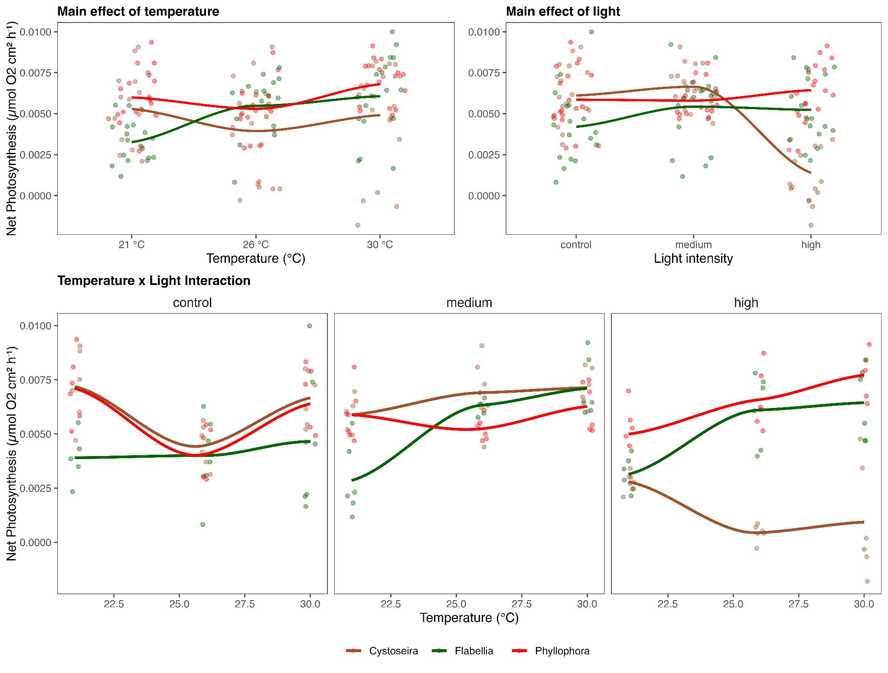

***Figure 1:*** *Observed responses of net photosynthesis to temperature and stress across three algal genera. (Top Left) The main effect of temperature on net photosynthesis for each species. (Top Right) The main effect of light intensity on net photosynthesis. (Bottom) Interaction effects between temperature and light intensity, with separate panels for each light treatment. Individual points represent observed data, and smoothed lines indicate species-specific loess trends.*

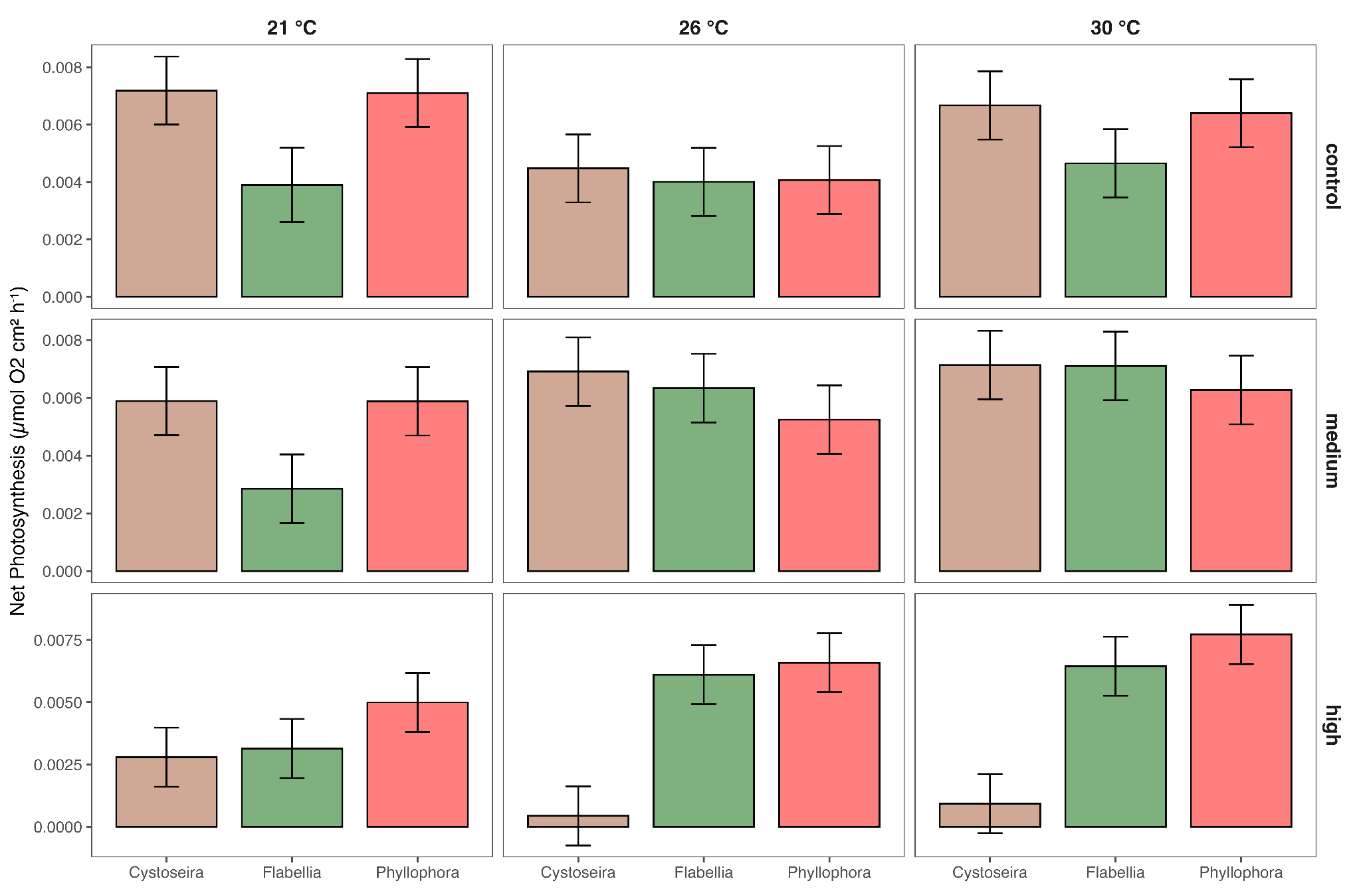

***Figure 2:*** *Model-based estimated marginal means of net photosynthesis in algae genera across environmental conditions. The panel x axis resembles temperature conditions, the panel y axis light conditions. Bars show estimated net photosynthesis per algae genus with error bars representing 95% confidence intervals.*

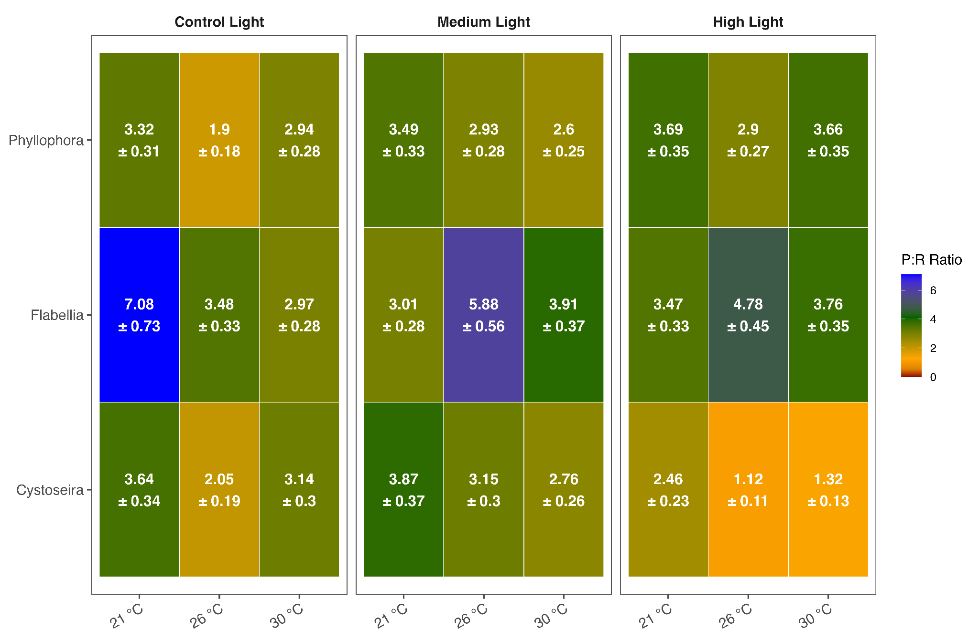

***Figure 3:*** *Heatmap depicting the estimated marginal means of the P:R ratio for three algal genera under different and light conditions. Colours represent metabolic imbalance (red, P:R < 1), moderate autotrophy (orange-yellow, 1 ≤ P:R < 3), stable metabolic conditions (green, 3 ≤ P:R < 5), and strong autotrophy with high photosynthetic efficiency (blue, P:R >5). The text indicates the estimated mean P:R ratio ± standard error.*

## 

## 

**Discussion**

We investigated how ocean warming and changes in light availability affect the photosynthetic performance and metabolic balance of three Mediterranean macroalgae. Our findings generally support the hypothesis that temperature and light act as major drivers of macroalgal physiology, with taxon-specific responses that may reshape future community structure. While thermal and light stress reduced photosynthetic efficiency across species, their combined effects intensified metabolic deficiency, particularly in sensitive taxa. These patterns suggest a directional shift in macroalgal dominance, with implications for marine biodiversity, habitat complexity, and ecosystem functioning under future climate scenarios.

In support of our first hypothesis, elevated temperatures led to a general decline in net photosynthesis and P:R ratios, though responses varied by genus. *Cystoseira* exhibited the steepest reduction in photosynthetic performance under warming, confirming its low thermal tolerance. The marked decline in both net O₂ production and metabolic balance under elevated temperatures aligns with field observations of *Cystoseira* canopy loss following marine heatwaves in the Mediterranean (Garrabou et al., 2022). This vulnerability likely reflects biochemical constraints, including increased saturation of thylakoid membrane lipids at high temperatures, which reduce membrane fluidity and impair electron transport efficiency (Goss & Latowski, 2020). Elevated respiration rates further eroded net carbon gain, potentially leading to a shift toward heterotrophy under future warming scenarios (Manhaeghe et al., 2019; Scharfenberger et al., 2019). In contrast, *Phyllophora* maintained stable photosynthesis with only moderate declines in P:R ratio, while *Flabellia* sustained elevated photosynthetic performance across all temperatures. These results confirm that red and green algae can exhibit higher thermal resilience than brown canopy-formers (Maltsev et al., 2021), partly due to photoprotective adaptations such as non-photochemical quenching (Talarico & Maranzana, 2000) and carbon-concentrating mechanisms (Hu et al., 2023).

We also found evidence in support of our second hypothesis, suggesting that light availability modulates photosynthetic performance in a species-specific manner. All algae showed reduced net photosynthesis under high-light stress, but only *Cystoseira* exhibited near-complete functional collapse at 760 µmol photons m⁻² s⁻¹. This suggests a limited capacity for photoprotection and high susceptibility to photoinhibition (Hanelt, 1995). By contrast, *Phyllophora* maintained stable performance under high irradiance, likely aided by UV-screening compounds such as mycosporine-like amino acids (Goss & Latowski, 2020), while *Flabellia* reached peak performance under intermediate light levels. This light saturation pattern is consistent with thresholds observed in tropical and subtropical chlorophytes (Henley, 1993; Wiencke et al., 1993), further highlighting the metabolic flexibility of opportunistic green algae.

Finally, our findings confirmed our third hypothesis by virtue of the significant interaction between temperature and light, which amplified stress effects beyond their individual impacts. *Cystoseira* exhibited near-zero photosynthesis and P:R ratios approaching 1 under combined high temperature and light, indicating imminent metabolic collapse. In contrast, *Phyllophora* showed slightly elevated photosynthesis under intermediate dual stress, and *Flabellia* maintained the highest P:R ratios across all treatment combinations. These results underscore the importance of testing multi-stressor interactions rather than evaluating marginal factors in isolation, as climate change is expected to simultaneously raise temperature and alter light regimes through stratification and eutrophication (Parras-Berrocal et al., 2020b; Pastor et al., 2024).

Our findings raise direct implications for novel coexistence patterns under climate change scenarios. Canopy-forming *Cystoseira* are foundational species that structure benthic assemblages by enhancing three-dimensional complexity, stabilizing substrates, and supporting rich epiphytic and faunal communities (Verdura et al., 2019). Their decline under combined thermal and light stress mirrors long-term observational studies documenting retreat and fragmentation of *Cystoseira* forests throughout the Mediterranean (Arriaga et al., 2023). Recruitment bottlenecks further limit recovery, particularly under warmer conditions where early life stages fail to develop (Falace et al., 2021). In contrast, *Flabellia* showed strong physiological performance under warming and light stress, consistent with recent reports of its expansion into northern ranges (Díaz et al., 2019) and with observed increases in mat-forming algal cover under warming and eutrophication (El-Khaled et al., 2023).

These shifts in physiological resistance support the possibility of a broader restructuring of benthic macroalgal communities, from structurally complex, canopy-dominated systems to flatter assemblages dominated by mats and turf-forming taxa. While *Flabellia* and *Phyllophora* could act as alternative ecosystem engineers by modifying light and flow regimes and hosting invertebrate fauna (Rossbach et al., 2022), they offer less vertical complexity. *Flabellia* may contribute to the stability of *Posidonia oceanica* meadows (Mancuso et al., 2024; Smith et al., 2023), but cannot replace the full range of ecosystem functions provided by *Cystoseira* forests. Reduced structural complexity may lead to declines in associated biodiversity (Cornwall et al., 2025) while lower P:R ratios under combined stress suggest a potential decline in primary productivity and carbon sequestration capacity.

With Mediterranean water temperatures projected to rise by 1.5–3.1 °C by 2100 and increased stratification expected to suppress nutrient mixing (Parras-Berrocal et al., 2020b; Zhao et al., 2024), our findings suggest that metabolic thresholds will increasingly be exceeded, particularly in sensitive foundation species. Feedback loops – including light attenuation and sediment accumulation driven by expanding algal mats – may further inhibit *Cystoseira* recruitment, locking ecosystems into degraded states (Johns et al., 2018; van de Vijsel et al., 2021).

While our experiment was designed to isolate temperature and light effects under controlled conditions, *in situ* responses may be influenced by additional variables such as herbivory, seasonal irradiance cycles, and hydrodynamics (Duran et al., 2016). Future research should extend these findings using long-term, field-based experiments that integrate nutrient availability, acidification, and biotic interactions to evaluate community resilience and identify thresholds for functional collapse. Our findings provide experimentally grounded evidence that temperature and light interact to shape macroalgal metabolic performance in a taxon-specific manner, driving divergent stress responses that foreshadow future shifts in Mediterranean benthic communities. This highlights the urgent need for targeted monitoring and protection of thermally sensitive primary producers such as *Cystoseira*, whose loss could trigger cascading ecological effects. As climate change accelerates, a mechanistic understanding of species-specific resilience will be essential for safeguarding the structure and function of coastal ecosystems.

**Acknowledgements**

We thank [...]

**Data availability**

The data and R code to reproduce the analysis are openly available in the associated [GitHub Repository](https://github.com/MerlinWe/algae_photosynthesis).

**Conflict of Interest**

The Authors declare they have no conflicts of interests.

**Funding**

*[Was there any?]*

**Author contribution**

Conceptualization: LH, CW

Methodology: LH, …, MW

Data collection: …

Formal Analysis: LH, MW

Writing (original draft): LH

Writing – review & editing: LH, MW, CW, …

Supervision: CW

All authors read, reviewed, and approved the final manuscript.

**References**

Arriaga, O., Wawrzynkowski, P., Ibáñez, H., Muguerza, N., Díez, I., Pérez-Ruzafa, I., Gorostiaga, J. M., Quintano, E., & Becerro, M. A. (2023). Short-term response of macroalgal communities to ocean warming in the Southern Bay of Biscay. *Marine Environmental Research*, *190*, 106098. https://doi.org/10.1016/j.marenvres.2023.106098

Bates, D., Mächler, M., Bolker, B., & Walker, S. (2015). Fitting Linear Mixed-Effects Models Using lme4. *Journal of Statistical Software*, *67*, 1-48. https://doi.org/10.18637/jss.v067.i01

Cloern, J., Foster, S., & Kleckner, A. (2014). Phytoplankton primary production in the world’s estuarine-coastal ecosystems. *Biogeosciences*, *11*. https://doi.org/10.5194/bg-11-2477-2014

Cornwall, C. E., Nelson ,Wendy A., Aguirre ,J. David, Blain ,Caitlin O., Coyle ,Lucy, D’Archino ,Roberta, Desmond ,Matthew J., Hepburn ,Christopher D., Liggins ,Libby, Shears ,Nick T., & and Thomsen, M. S. (2025). Predicting the impacts of climate change on New Zealand’s seaweed-based ecosystems. *New Zealand Journal of Botany*, *63*(1), 1-27. https://doi.org/10.1080/0028825X.2023.2245786

Crafts-Brandner, S. J., & Salvucci, M. E. (2000). Rubisco activase constrains the photosynthetic potential of leaves at high temperature and CO2. *Proceedings of the National Academy of Sciences of the United States of America*, *97*(24), Article 24.

Díaz, P., Baldock, L., & Maggs, C. (2019). Discovery of Flabellia petiolata (Halimedaceae, Chlorophyta) in the southern British Isles: A relict population or a new introduction? *Aquatic Botany*, *160*, 103160. https://doi.org/10.1016/j.aquabot.2019.103160

D’Ortenzio, F., & Ribera d’Alcalà, M. (2009). On the trophic regimes of the Mediterranean Sea: A satellite analysis. *Biogeosciences*, *6*(2), 139-148. https://doi.org/10.5194/bg-6-139-2009

Duran, A., Collado-Vides, L., & Burkepile, D. (2016). Seasonal regulation of herbivory and nutrient effects on macroalgal recruitment and succession in a Florida coral reef. *PeerJ*, *4*. https://doi.org/10.7717/peerj.2643

El-Khaled, Y., Tilstra, A., Mezger, S., & Wild, C. (2023). Red and brown algae mats overgrow classical marine biodiversity hotspots in the Mediterranean Sea. *Bulletin of Marine Science*, *99*, 51-55. https://doi.org/10.5343/bms.2022.0020

Falace, A., Marletta, G., Savonitto, G., Candotto Carniel, F., Srijemsi, M., Bevilacqua, S., Tretiach, M., & Alongi, G. (2021). Is the South-Mediterranean Canopy-Forming Ericaria giacconei (= Cystoseira hyblaea) a Loser From Ocean Warming? *Frontiers in Marine Science*, *8*. https://doi.org/10.3389/fmars.2021.760637

Gao, G., Zhao, X., Jiang, M., & Gao, L. (2021). Impacts of Marine Heatwaves on Algal Structure and Carbon Sequestration in Conjunction With Ocean Warming and Acidification. *Frontiers in Marine Science*, *8*. https://doi.org/10.3389/fmars.2021.758651

Garrabou, J., Coma, R., Bensoussan, N., Bally, M., Chevaldonné, P., Cigliano, M., Diaz, D., Harmelin, J. G., Gambi, M. C., Kersting, D. K., Ledoux, J. B., Lejeusne, C., Linares, C., Marschal, C., Pérez, T., Ribes, M., Romano, J. C., Serrano, E., Teixido, N., … Cerrano, C. (2009). Mass mortality in Northwestern Mediterranean rocky benthic communities: Effects of the 2003 heat wave. *Global Change Biology*, *15*(5), 1090-1103. https://doi.org/10.1111/j.1365-2486.2008.01823.x

Garrabou, J., Gómez‐Gras, D., Medrano, A., Cerrano, C., Ponti, M., Schlegel, R., Bensoussan, N., Turicchia, E., Sini, M., Gerovasileiou, V., Teixido, N., Mirasole, A., Tamburello, L., Cebrian, E., Rilov, G., Ledoux, J., Souissi, J. B., Khamassi, F., Ghanem, R., … Harmelin, J. (2022). Marine heatwaves drive recurrent mass mortalities in the Mediterranean Sea. *Global Change Biology*, *28*(19), Article 19. https://doi.org/10.1111/gcb.16301

Goss, R., & Latowski, D. (2020). Lipid Dependence of Xanthophyll Cycling in Higher Plants and Algae. *Frontiers in Plant Science*, *11*. https://doi.org/10.3389/fpls.2020.00455

Hanelt, D. (1995). Photoinhibition of photosynthesis in marine macroalgae. *Scientia Marina*, *60*, 243-248.

Henley, W. J. (1993). Measurement and Interpretation of Photosynthetic Light-Response Curves in Algae in the Context of Photoinhibition and Diel Changes. *Journal of Phycology*, *29*(6), 729-739. https://doi.org/10.1111/j.0022-3646.1993.00729.x

Hobday, A. J., Oliver, E. C. J., Gupta, A. S., Benthuysen, J. A., & Burrows, M. T. (2018). Categorizing and Naming Marine Heatwaves. *Oceanography*, *31*(2), 162-173. https://doi.org/10.5670/oceanog.2018.205

Hu, J., Meng, W., Su, Y., Qian, C., & Fu, W. (2023). Emerging technologies for advancing microalgal photosynthesis and metabolism toward sustainable production. *Frontiers in Marine Science*, *10*. https://doi.org/10.3389/fmars.2023.1260709

Ji, Y., & Gao, K. (2021). Chapter Two - Effects of climate change factors on marine macroalgae: A review. In C. Sheppard (Red.), *Advances in Marine Biology* (Vol. 88, pp. 91-136). Academic Press. https://doi.org/10.1016/bs.amb.2020.11.001

Ji, Y., Xu, Z., Zou, D., & Gao, K. (2016). Ecophysiological responses of marine macroalgae to climate change factors. *Journal of Applied Phycology*, *28*(5), 2953-2967. https://doi.org/10.1007/s10811-016-0840-5

Johns, K. A., Emslie, M. J., Hoey, A. S., Osborne, K., Jonker, M. J., & Cheal, A. J. (2018). Macroalgal feedbacks and substrate properties maintain a coral reef regime shift. *Ecosphere*, *9*(7), e02349. https://doi.org/10.1002/ecs2.2349

Karlsson, J., Byström, P., Ask, J., Ask, P., Persson, L., & Jansson, M. (2009). Light limitation of nutrient-poor lake ecosystems. *Nature*, *460*(7254), 506-509. https://doi.org/10.1038/nature08179

Lenth, R. V. (2017). *emmeans: Estimated Marginal Means, aka Least-Squares Means* (p. 1.10.7) [Dataset]. https://doi.org/10.32614/CRAN.package.emmeans

Li, M., Organelli, E., Serva, F., Bellacicco, M., Landolfi, A., Pisano, A., Marullo, S., Shen, F., Mignot, A., van Gennip, S., & Santoleri, R. (2024). Phytoplankton Spring Bloom Inhibited by Marine Heatwaves in the North-Western Mediterranean Sea. *Geophysical Research Letters*, *51*(20), e2024GL109141. https://doi.org/10.1029/2024GL109141

Maltsev, Y., Maltseva, K., Kulikovskiy, M., & Maltseva, S. (2021). Influence of Light Conditions on Microalgae Growth and Content of Lipids, Carotenoids, and Fatty Acid Composition. *Biology*, *10*(10), Article 10. https://doi.org/10.3390/biology10101060

Mancuso, F. P., Sarà, G., & Mannino, A. M. (2024). Conserving Marine Forests: Assessing the Effectiveness of a Marine Protected Area for Cystoseira sensu lato Populations in the Central Mediterranean Sea. *Plants*, *13*(2), Article 2. https://doi.org/10.3390/plants13020162

Manhaeghe, D., Michels, S., Rousseau, D. P. L., & Van Hulle, S. W. H. (2019). A semi-mechanistic model describing the influence of light and temperature on the respiration and photosynthetic growth of *Chlorella vulgaris*. *Bioresource Technology*, *274*, 361-370. https://doi.org/10.1016/j.biortech.2018.11.097

Parras-Berrocal, I. M., Vazquez, R., Cabos, W., Sein, D., Mañanes, R., Perez-Sanz, J., & Izquierdo, A. (2020a). The climate change signal in the Mediterranean Sea in a regionally coupled atmosphere–ocean model. *Ocean Science*, *16*(3), 743-765. https://doi.org/10.5194/os-16-743-2020

Parras-Berrocal, I. M., Vazquez, R., Cabos, W., Sein, D., Mañanes, R., Perez-Sanz, J., & Izquierdo, A. (2020b). The climate change signal in the Mediterranean Sea in a regionally coupled atmosphere–ocean model. *Ocean Science*, *16*(3), Article 3. https://doi.org/10.5194/os-16-743-2020

Pastor, F., Paredes-Fortuny, L., & Khodayar, S. (2024). Mediterranean marine heatwaves intensify in the presence of concurrent atmospheric heatwaves. *Communications Earth & Environment*, *5*(1), Article 1. https://doi.org/10.1038/s43247-024-01982-8

Pastor, F., Valiente, J. A., & Palau, J. L. (2018). Sea Surface Temperature in the Mediterranean: Trends and Spatial Patterns (1982–2016). *Pure and Applied Geophysics*, *175*(11), 4017-4029. https://doi.org/10.1007/s00024-017-1739-z

Raven, J. A., & Geider, R. J. (2003). Adaptation, Acclimation and Regulation in Algal Photosynthesis. In A. W. D. Larkum, S. E. Douglas, & J. A. Raven (Red.), *Photosynthesis in Algae* (pp. 385-412). Springer Netherlands. https://doi.org/10.1007/978-94-007-1038-2_17

Raven, J. A., & Hurd, C. L. (2012). Ecophysiology of photosynthesis in macroalgae. *Photosynthesis Research*, *113*(1), 105-125. https://doi.org/10.1007/s11120-012-9768-z

Reiskind, J. B., Beer, S., & Bowes, G. (1989). Photosynthesis, photorespiration and ecophysiological interactions in marine macroalgae. *Aquatic Botany*, *34*(1), 131-152. https://doi.org/10.1016/0304-3770(89)90053-3

Romero, E., Tenorio-Fernandez, L., Portela, E., Montes-Aréchiga, J., & Sánchez-Velasco, L. (2023). Improving the thermocline calculation over the global ocean. *Ocean Science*, *19*(3), 887-901. https://doi.org/10.5194/os-19-887-2023

Rossbach, F. I., Casoli, E., Plewka, J., Schmidt, N., & Wild, C. (2022). New Insights into a Mediterranean Sea Benthic Habitat: High Diversity of Epiphytic Bryozoan Assemblages on Phyllophora crispa (Rhodophyta) Mats. *Diversity*, *14*(5), Article 5. https://doi.org/10.3390/d14050346

Scharfenberger, U., Jeppesen, E., Beklioğlu, M., Søndergaard, M., Angeler, D. G., Çakıroğlu, A. İ., Drakare, S., Hejzlar, J., Mahdy, A., Papastergiadou, E., Šorf, M., Stefanidis, K., Tuvikene, A., Zingel, P., & Adrian, R. (2019). Effects of trophic status, water level, and temperature on shallow lake metabolism and metabolic balance: A standardized pan-European mesocosm experiment. *Limnology and Oceanography*, *64*(2), 616-631. https://doi.org/10.1002/lno.11064

Schmidt, N., El-Khaled, Y. C., Roßbach, F. I., & Wild, C. (2021). Fleshy Red Algae Mats Influence Their Environment in the Mediterranean Sea. *Frontiers in Marine Science*, *8*. https://doi.org/10.3389/fmars.2021.721626

Shi, X., Zou, D., Hu, S., Mai, G., Ma, Z., & Li, G. (2021). Photosynthetic Characteristics of Three Cohabitated Macroalgae in the Daya Bay, and Their Responses to Temperature Rises. *Plants*, *10*(11), Article 11. https://doi.org/10.3390/plants10112441

Smith, C. J., Verdura, J., Papadopoulou, N., Fraschetti, S., Cebrian, E., Fabbrizzi, E., Monserrat, M., Drake, M., Bianchelli, S., Danovaro, R., Malak, D. A., Ballesteros, E., Benjumea Tesouro, T., Boissery, P., D’Ambrosio, P., Galobart, C., Javel, F., Laurent, D., Orfanidis, S., & Mangialajo, L. (2023). A decision-support framework for the restoration of Cystoseira sensu lato forests. *Frontiers in Marine Science*, *10*. https://doi.org/10.3389/fmars.2023.1159262

Szalińska, E., Orlińska-Woźniak, P., Wilk, P., Jakusik, E., Skalák, P., Wypych, A., & Arnold, J. (2024). Sediment load assessments under climate change scenarios and a lack of integration between climatologists and environmental modelers. *Scientific Reports*, *14*(1), 21727. https://doi.org/10.1038/s41598-024-72699-z

Tait, L. W., & Schiel, D. R. (2018). Ecophysiology of Layered Macroalgal Assemblages: Importance of Subcanopy Species Biodiversity in Buffering Primary Production. *Frontiers in Marine Science*, *5*. https://doi.org/10.3389/fmars.2018.00444

Talarico, L., & Maranzana, G. (2000). Light and adaptive responses in red macroalgae: An overview1. *Journal of Photochemistry and Photobiology B: Biology*, *56*(1), Article 1. https://doi.org/10.1016/S1011-1344(00)00046-4

Tiralongo, F., Okan, A., Battaglia, P., Beton, D., Bitlis, B., Borg, J. A., Bouchoucha, M., Çinar, M. E., Crocetta, F., & Dragičević, B. (2022). *New alien Mediterranean biodiversity records (August 2022)*. https://www.um.edu.mt/library/oar/handle/123456789/101461

Trégarot, E., D’Olivo, J. P., Botelho, A. Z., Cabrito, A., Cardoso, G. O., Casal, G., Cornet, C. C., Cragg, S. M., Degia, A. K., Fredriksen, S., Furlan, E., Heiss, G., Kersting, D. K., Maréchal, J.-P., Meesters, E., O’Leary, B. C., Pérez, G., Seijo-Núñez, C., Simide, R., … de Juan, S. (2024a). Effects of climate change on marine coastal ecosystems – A review to guide research and management. *Biological Conservation*, *289*, 110394. https://doi.org/10.1016/j.biocon.2023.110394

Trégarot, E., D’Olivo, J. P., Botelho, A. Z., Cabrito, A., Cardoso, G. O., Casal, G., Cornet, C. C., Cragg, S. M., Degia, A. K., Fredriksen, S., Furlan, E., Heiss, G., Kersting, D. K., Maréchal, J.-P., Meesters, E., O’Leary, B. C., Pérez, G., Seijo-Núñez, C., Simide, R., … de Juan, S. (2024b). Effects of climate change on marine coastal ecosystems – A review to guide research and management. *Biological Conservation*, *289*, 110394. https://doi.org/10.1016/j.biocon.2023.110394

Tsirintanis, K., Azzurro, E., Crocetta, F., Dimiza, M., Froglia, C., Gerovasileiou, V., Langeneck, J., Mancinelli, G., Rosso, A., & Stern, N. (2022). Bioinvasion impacts on biodiversity, ecosystem services, and human health in the Mediterranean Sea. *Aquatic invasions*, *17*(3), 308-352.

Uitz, J., Claustre, H., Gentili, B., & Stramski, D. (2010). Phytoplankton class-specific primary production in the world’s oceans: Seasonal and interannual variability from satellite observations. *Global Biogeochemical Cycles*, *24*(3). https://doi.org/10.1029/2009GB003680

van de Vijsel, R. C., van Belzen, J., Bouma, T. J., van der Wal, D., & van de Koppel, J. (2021). Algal-Induced Biogeomorphic Feedbacks Lay the Groundwork for Coastal Wetland Development. *Journal of Geophysical Research: Biogeosciences*, *126*(10), e2021JG006515. https://doi.org/10.1029/2021JG006515

Verdura, J., Linares, C., Ballesteros, E., Coma, R., Uriz, M. J., Bensoussan, N., & Cebrian, E. (2019). Biodiversity loss in a Mediterranean ecosystem due to an extreme warming event unveils the role of an engineering gorgonian species. *Scientific Reports*, *9*(1), Article 1. https://doi.org/10.1038/s41598-019-41929-0

Wiencke, C., Rahmel, J., Karsten, U., Weykam, G., & Kirst, G. O. (1993). Photosynthesis of Marine Macroalgae from Antarctica: Light and Temperature Requirements. *Botanica Acta*, *106*(1), Article 1. https://doi.org/10.1111/j.1438-8677.1993.tb00341.x

Zhao, J., Zhao, B., Kong, N., Li, M., Li, F., Liu, J., Wang, L., & Song, L. (2024). Water stratification alters phytoplankton assemblages in scallop farming waters of the North Yellow Sea in China. *Marine Environmental Research*, *196*, 106399. https://doi.org/10.1016/j.marenvres.2024.106399

Zuur, A. F., Ieno, E. N., & Elphick, C. S. (2010). A protocol for data exploration to avoid common statistical problems. *Methods in Ecology and Evolution*, *1*(1), 3-14. https://doi.org/10.1111/j.2041-210X.2009.00001.x

**Supplementary Material**

***Table S-1:*** *Parameter estimates from the top model testing the effects of temperature, light, genus, and their interactions on net photosynthesis (µmol O₂ cm⁻² h⁻¹).*

| Parameter | Estimate | SE | T Ratio | p-value |
| --- | --- | --- | --- | --- |
| (Intercept) | 0.007 | 0.001 | 11.983 | 0.000 |
| **Temperature 26°C** | **-0.003** | **0.001** | **-3.198** | **0.002** |
| Temperature 30°C | -0.001 | 0.001 | -0.614 | 0.540 |
| Light medium | -0.001 | 0.001 | -1.533 | 0.128 |
| **Light high** | **-0.004** | **0.001** | **-5.183** | **0.000** |
| **Genus *Flabellia*** | **-0.003** | **0.001** | **-3.694** | **0.000** |
| Genus *Phyllophora* | -0.000 | 0.001 | -0.104 | 0.917 |
| **Temperature 26°C : Light medium** | **0.004** | **0.001** | **3.112** | **0.002** |
| Temperature 30°C : Light medium | 0.002 | 0.001 | 1.474 | 0.143 |
| Temperature 26°C: Light high | 0.000 | 0.001 | 0.300 | 0.764 |
| Temperature 30°C : Light high | -0.001 | 0.001 | -1.117 | 0.266 |
| **Temperature 26°C: Genus *Flabellia*** | **0.003** | **0.001** | **2.290** | **0.024** |
| Temperature 30°C : Genus *Flabellia* | 0.001 | 0.001 | 1.033 | 0.303 |
| Temperature 26°C : Genus *Phyllophora* | -0.000 | 0.001 | -0.266 | 0.791 |
| Temperature 30°C : Genus *Phyllophora* | -0.000 | 0.001 | -0.152 | 0.879 |
| Light medium : Genus *Flabellia* | 0.000 | 0.001 | 0.203 | 0.839 |
| **Light high : Genus *Flabellia*** | **0.004** | **0.001** | **2.959** | **0.004** |
| Light medium : Genus *Phyllophora* | 0.000 | 0.001 | 0.067 | 0.946 |
| Light high : Genus *Phyllophora* | 0.002 | 0.001 | 1.909 | 0.058 |
| Temperature 26°C : Light medium : Genus *Flabellia* | -0.000 | 0.002 | -0.206 | 0.837 |
| Temperature 30°C : Light medium : Genus *Flabellia* | 0.002 | 0.002 | 1.009 | 0.315 |
| Temperature 26°C : Light high : Genus *Flabellia* | 0.003 | 0.002 | 1.456 | 0.148 |
| **Temperature 30°C : Light high : Genus *Flabellia*** | **0.004** | **0.002** | **2.264** | **0.025** |
| Temperature 26°C : Light medium : Genus *Phyllophora* | -0.001 | 0.002 | -0.789 | 0.432 |
| Temperature 30°C : Light medium : Genus *Phyllophora* | -0.001 | 0.002 | -0.398 | 0.691 |
| **Temperature 26°C : Light high : Genus *Phyllophora*** | **0.004** | **0.002** | **2.513** | **0.013** |
| **Temperature 30°C : Light high : Genus *Phyllophora*** | **0.005** | **0.002** | **2.810** | **0.006** |

*Significant effects (p < 0.05) are highlighted in bold. Interaction terms represent the combined effects of multiple predictors, indicating deviations from additive effects.*

***Table S-2:*** *Pairwise comparisons of genera under varying temperature and light conditions, estimated using marginal means from the final model.*

| Contrast | Temperature | Light | Estimate | SE | DF | T Ratio | p-value |
| --- | --- | --- | --- | --- | --- | --- | --- |
| ***Cystoseira - Flabellia*** | **21°C** | **control** | **0.003** | 0.001 | 134 | 3.694 | **0.001** |
| *Cystoseira - Phyllophora* | 21°C | control | 0.000 | 0.001 | 134 | 0.104 | 0.994 |
| ***Flabellia - Phyllophora*** | **21°C** | **control** | **-0.003** | 0.001 | 134 | -3.595 | **0.001** |
| *Cystoseira - Flabellia* | 26°C | control | 0.000 | 0.001 | 134 | 0.555 | 0.844 |
| *Cystoseira - Phyllophora* | 26°C | control | 0.000 | 0.001 | 134 | 0.480 | 0.881 |
| *Flabellia - Phyllophora* | 26°C | control | -0.000 | 0.001 | 134 | -0.076 | 0.997 |
| ***Cystoseira - Flabellia*** | **30°C** | **control** | **0.002** | 0.001 | 134 | 2.376 | **0.049** |
| *Cystoseira - Phyllophora* | 30°C | control | 0.000 | 0.001 | 134 | 0.319 | 0.946 |
| *Flabellia - Phyllophora* | 30°C | control | -0.002 | 0.001 | 134 | -2.057 | 0.103 |
| ***Cystoseira - Flabellia*** | **21°C** | **medium** | **0.003** | 0.001 | 134 | 3.579 | **0.001** |
| *Cystoseira - Phyllophora* | 21°C | medium | 0.000 | 0.001 | 134 | 0.009 | 1.000 |
| ***Flabellia - Phyllophora*** | **21°C** | **medium** | **-0.003** | 0.001 | 134 | -3.570 | **0.001** |
| *Cystoseira - Flabellia* | 26°C | medium | 0.001 | 0.001 | 134 | 0.677 | 0.777 |
| *Cystoseira - Phyllophora* | 26°C | medium | 0.002 | 0.001 | 134 | 1.962 | 0.126 |
| *Flabellia - Phyllophora* | 26°C | medium | 0.001 | 0.001 | 134 | 1.284 | 0.406 |
| *Cystoseira - Flabellia* | 30°C | medium | 0.000 | 0.001 | 134 | 0.038 | 0.999 |
| *Cystoseira - Phyllophora* | 30°C | medium | 0.001 | 0.001 | 134 | 1.020 | 0.566 |
| *Flabellia - Phyllophora* | 30°C | medium | 0.001 | 0.001 | 134 | 0.982 | 0.590 |
| *Cystoseira - Flabellia* | 21°C | high | -0.000 | 0.001 | 134 | -0.414 | 0.910 |
| ***Cystoseira - Phyllophora*** | **21°C** | **high** | **-0.002** | 0.001 | 134 | -2.596 | **0.028** |
| *Flabellia - Phyllophora* | 21°C | high | -0.002 | 0.001 | 134 | -2.182 | 0.078 |
| ***Cystoseira - Flabellia*** | **26°C** | **high** | **-0.006** | 0.001 | 134 | -6.681 | **0.000** |
| ***Cystoseira - Phyllophora*** | **26°C** | **high** | **-0.006** | 0.001 | 134 | -7.246 | **0.000** |
| *Flabellia - Phyllophora* | 26°C | high | -0.000 | 0.001 | 134 | -0.565 | 0.839 |
| ***Cystoseira - Flabellia*** | **30°C** | **high** | **-0.006** | 0.001 | 134 | -6.497 | **0.000** |
| ***Cystoseira - Phyllophora*** | **30°C** | **high** | **-0.007** | 0.001 | 134 | -8.001 | **0.000** |
| *Flabellia - Phyllophora* | 30°C | high | -0.001 | 0.001 | 134 | -1.504 | 0.292 |

*Tukey-adjusted p-values are reported to account for multiple comparisons.*

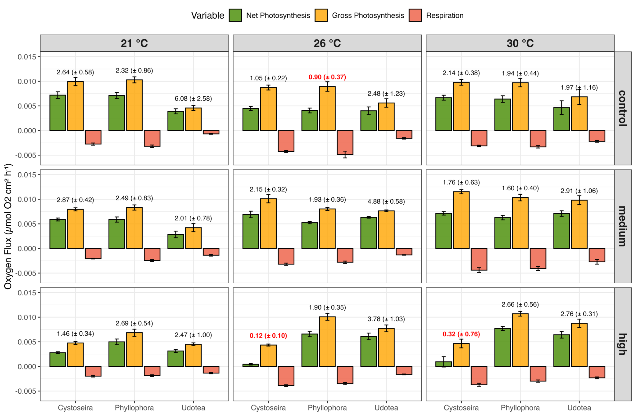

***Figure S-1****: Net and gross photosynthesis and respiration rates of three algal genera (Cystoseira., Phyllophora, and Flabellia) under three temperature conditions (21 °C, 26 °C, 30 °C) and varying light intensities (control, medium, high). Bars represent oxygen flux (μmol O₂ cm⁻² h⁻¹) with standard deviations. The small numbers above the bars indicate the P:R ratio. Significant differences in the measured parameters are highlighted in red color.*